Swajan stories 2010

This document is for internal use only. It is a source of stories which can be adapted for use in Traidcraft publications, website, resources etc, but should not be passed on in this format.

These producer stories relate to photographs taken by GMB Akash in September 2010. Some images are included and there are more on TIM.

Background information from managing partner Bimal Banik

There are up to 30 women working on pasting cards and new samples depending on the number of orders. There are around 850 women – master embroiderers – working in nine groups in Dhaka and around Bangladesh.

“They have all year round work. June and July is quieter. In that time the girls who are on daily wages, we do not leave them. We just keep them doing some work, just to keep them otherwise we will lose them, they will disappear.

“Sometimes they go and come, because they are living in slums or sometimes their husbands are moving from one place to another place or their family is moving. They love to work here but sometimes because of the family situation they cannot come here.”

Bimal described the situation in Dhaka and why the work suits women who live close to Swajan’s premises and workshops. “We have traffic problems. It can take two or three hours to come here, two or three hours to go so sometimes they do not want to continue.

“The girls working here live quite close. If there is no traffic they get here in maybe 15 minutes time.”

I have started my life here – Dipa’s story

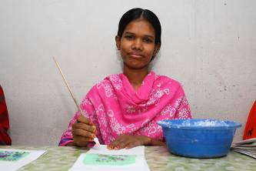
Halima Akhtar, nickname Dipa, completed Grade 10 at school, but failed her final exam. Now 20, she has been working at Swajan for three years, quality checking the cards and pasting the fabric insets.

“When I failed in my final exam I was sitting idle and I thought I should do something to earn for my family,” she said. “I did not want to work in the garment industry. This is my first job. I have started my life here and I have found it very interesting, I love it.”

Dipa found out about Swajan through her uncle, who works in Swajan’s tailoring unit. Many of the cards sold by Traidcraft will have been checked and pasted by Dipa.

“I check if there are any beads or stitches missing or any dirty marks on the cards or fabric then I do the glue on the card,” she said.

Dipa has a brother and two sisters, one of whom she lives with in Dhaka. Her father died and her mother and brother still live and farm in the village where Dipa grew up.

“I am staying with my elder sister and working here,” she said. “I do not have to support my family but I am saving and I buy new clothes.”

When she saw the Swajan products in the Traidcraft catalogue she said: “When I see these I feel very happy and I feel very proud.”

Asked what she thought she would be doing in four years time, Dipa said : “In the next four years, if I have not got married, still I will be continuing working here. If I got married I don’t know where I will go and where I will stay, it will depend if I live near or if my husband will allow me to work or not.”

It is safe and secure – Neela’s story

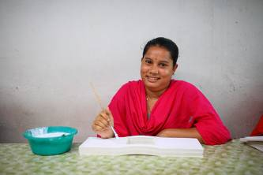
Neela Rani Das missed out on education once she reached Grade 5. That is when the government’s free primary school education comes to an end – and her family could not afford to pay for her to continue going to school.

She spent her time at home until her uncle, who is a cobbler, was cutting some leather for Swajan cushion covers, and suggested she apply for work there.

Now the 19-year-old has been at Swajan for three years and it has changed her life.

“I love working here. It is safe and secure. I can learn something new and there are regular payments without any delays. I have friends here, all of them are girls. I come here every day by walking, It takes only 15 minutes.”

Neela, who is the second youngest of four children, still lives with her parents.

“I have a saving scheme with the bank . I save 500 taka a month and the rest of the money I give to my father. I also have some to buy new clothes.”

It’s not just Neela and her uncle who have a working relationship with Swajan, as Bimal Banik explained. “Her father is a vegetable seller in the market. We buy some vegetables, such as limes, when we need them.”

When Neela saw Swajan products in the Traidcraft catalogue she said: “I feel very good, very happy because we have done these works.”

I am saving for my sister’s wedding – Rita Rani’s story

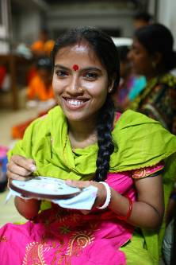
As a child Rita Rani used to come to Swajan with her mother who was one of the embroiderers. Now Rita is one of the women making the beautiful cards and purses sold by Traidcraft – and described as one of the best embroiderers and appliqué workers by managing partner Bimal Banik.

“Her mother was working with us from the beginning,” said Bimal. “When Rita was very tining her mother would bring her to give some training so it started that way. Three or four years back her mother died. Rita is one of the best embroiderers and appliqué workers.”

Rita (22) went to school until Grade 8. She is married and her husband, Nirmal Shil, works as a barber in a shop near Swajan in Dhaka. Because both her parents are dead, Rita’s 13-year-old sister, Anima Rani, lives with Rita and Nirmal and is depending on them to provide for her wedding.

“I am saving for my sister’s wedding,” Rita said. “I feel very good working here. I love to work here, I feel very secure. Whatever I am earning from her my husband is keeping only 500 take, the rest he is paying into the back.

Everyone is friendly – Seikh Alo’s story

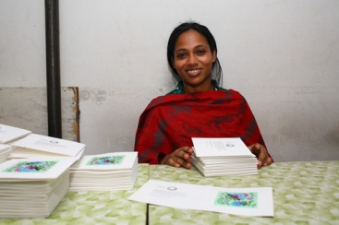
For Alo, working at Swajan provides her with friendship. The 22-year-old, who began working for Swajan when she was 20, found life hard when she was growing up as her parents had died.
“When I was born my mother died. I cannot remember my father’s face because I was too little,” she said. Alo lived with an aunt until she was 19, but then her aunt could not afford to look aftrer her anymore.

“I was doing nothing,” Alo said. “I do not have a father or mother and when I was sitting idle at home I was not feeling very comfortable. My cousin’s sister is one of the supervisors and I came here through her.”

Now Alo, who has no brothers or sisters, lives in a dormitory with several other girls.

“I am living on my own with my earned money,” she said. “I did not go to school but I can read and write a little bit.”

At Swajan she inspects the cards and fabrics, checking the quality of the printed cards and doing some ironing, cutting, pasting and packaging. Her favourite work is pasting.

“Everybody is friendly with me and everybody is friendly with everybody,” she said.

They feel comfortable – Parveen Islam’s story

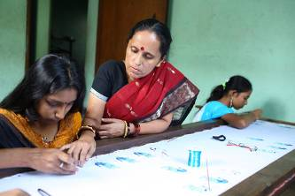
Parveen Islam is supervisor of the Swajan workshop in Middle Badda, Dhaka, where around 40 women embroider. She has been working with Swajan for more than 13 years. As well as training new women, she fetches the raw materials for Traidcraft orders from Swajan and confirms the delivery date. Each woman then works on the order, with Parveen collecting the finished products, checking the quality and delivering to Swajan. The women are paid by the number of pieces that they do.

Parveen explained why the work provided is important for the women.

“We have those who are facing financial problems and those who don’t want to go to garment factories. They can go to school with their children and then bring their children here. They are getting this kind of opportunity from here so they feel comfortable. They can go to their home for cooking. Other places, they are 9 to 5pm and no way of going out.

“When they start coming I give them some idea about the product, what is the technique and give them some training for two or three months. They are doing easy stitches to begin with.”

I look after any problems – Amena’s story

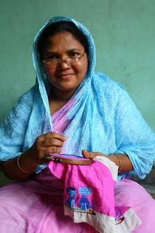
(Amena’s story features in the Swajan Stories 2006 document on TIM (ref 4948) and she has featured in the Traidcraft catalogue. She also features in the A4 Meet Our Producers card, ref 34552.)

Amena, who has been working for Swajan for more than 12 years, is now a members of the workers’ committee in her workshop. There are five women who represent the women and ensure that their concerns and needs have a voice.

“I look after any problems. If anyone working here stops coming or if we face a problem, like a delivery date, I would discuss with the supervisor.” Amena said.

She has three sons, Zaid, Zakir and Jamil, and in 2006 told Traidcraft: “My money is for their education. My husband and I use our money to look after our family. My wish is that my children will have a better life. I want to give them an education, that’s my main aim. I want my sons to get good jobs.”

“Still I am thinking that,” she said, when reminded of the interview. All three sons – now aged between 18 and 27 - are still living with her and Amena gave an update on what they are doing now.

“The first one has a marketing job, the second is in secondary high school and has passed the certificate and the third is going to sit the secondary school certificate exam,” she said.

Amena’s husband’s wages, along with Zaid’s salary, meet everyday expenses, including food, which means Amena’s income pays for her other sons’ education and she can save as well.

“I have a saving scheme in the bank and pay 1000 taka a month deposit,” she said. “My first son is trying to start up a business providing telephone and fax services for people and I am wanting to support him as he gets started.”

Asked why she has stayed working at Swajan for so many years, Amena replied: “I love here. Sometimes I walk here and sometimes come by rickshaw but most of the time by walking.

“I love to work here because I am getting good opportunities, like looking after my children and I can go off home frequently if necessary. I feel comfortable here.”

After seeing the products in the Traidcraft catalogue, she said: “We feel nice when we see them.”

I am saving for my har necklace – Rosy’s story

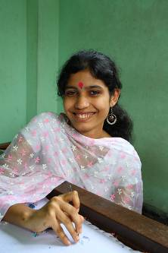
Rojina Akther, known as Rosy, is saving for the future – and knows exactly what she want to spend the money on.

She is one of five children and her father paid for the wedding jewellery worn by her two sisters when they married. But Rosy would like to meet the expense herself.

“I am saving 600 taka a month with a savings group. I am saving to buy my har,” she said, referring to the traditional gold necklace which she will wear at her wedding.

“My father is a vegetable seller and my mother does not work,” she said. “I give my money to my parents and sometimes I keep money for myself.”

Rosy (18) completed Class 8 in school and spent some time at home not doing anything before joining Swajan when she was 17.

“Somehow I knew there were some women who are working here. I came to the supervisor and got two months training. I feel good working here. Also it is quiet in this place.”

I am in a saving scheme – Rubi’s story

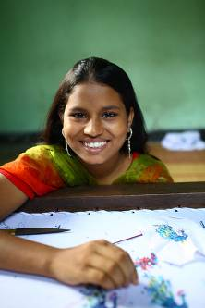
Sumiya Akhter, known as Rubi, joined Swajan after completing Class 8 at school. She and her father, a rickshaw puller, are the only ones earning money to support their family.

“My mother was working but is not well, so can’t work now. Nobody else is earning money,” Rubi said. Her money helps to support her two younger sisters and brother who are still at school. An older sister is married and no longer lives at home.

“I am in a saving scheme,” Rubi said. “I save 1000 taka a month and the rest of the money I give to my parents.”

The family lives in Middle Badda, which is why Rubi knew about the Swajan workshop close to her home.

“One of my aunties brought me here and the supervisor gave me training. I bring my lunch here, rice and some vegetables.”

Rubi, who embroiders and appliqués Traidcraft products, said: “I feel very happy when I see them in the catalogue.”

We are greatly learning – Soma’s story

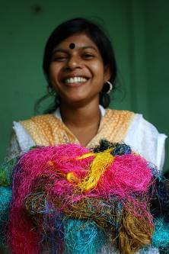
The beautiful mirrorwork on Traidcraft cards and purses is created by women like Soma Akhter, who was taught this traditional skill by Swajan after completing Class 9 at school.

Soma joined the workshop after a woman she knew introduced her to the supervisor and she was accepted for training in embroidery and mirrorwork.

“I am enjoying doing this,” she said. “First when we get a new design we are doing it carefully and see the sample lots of times. We are greatly learning. I save 500 take a month and the rest of the money I give to my parents.

“They buy me new clothes and things that I need, especially on special days and celebrations such as the Eid festival and New Year.”

Soma is the youngest of five children. All the others are married and she lives with her parents and her brother’s family. Soma’s father runs a grocery shop and her mother is not working.

On seeing Swajan products in the catalogue, she said: “I am very glad to see them.”

There is good work there – Nupur’s story

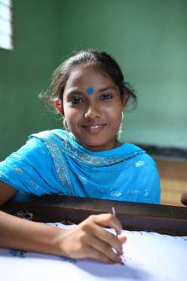
Farjana Akhter, who is known as Nupur, heard about the Swajan workshop through a friend and joined when she had completed Class 8 at school.

“One of my friends told me, we can go there. There is good work there,” she said. “I have been one year here.”

Nupur does the eye-catching mirrorwork on Traidcraft cards and purses. “It is very important what colour is put where,” she said. “When there is a new design I look carefully at what kind of technique is there. I am looking at the sample again and again.

Nupur lives at home with her father, who is a driver, her mother and her younger sister who is still at school.

“I am in a savings group, saving 300 taka a month, and the rest of the money I give to my parents.”

I buy milk for my daughter – Shila’s story

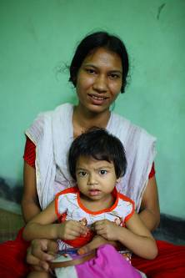
Working for Swajan means that Shila can earn money to provide for her two daughters, Anamika (2) and Rukshad (6).

The flexible arrangements mean that Shila (27) can take Rukshad to nursery and also collect her when it finishes.

“I am working here and bringing my children with me. Anamika is playing here while I am doing work. I also bring food.”

Shila’s husband works in a book showroom, but her salary is also important, as she explained. “Sometimes I buy milk for my daughter and vegetables from the market. When my husband delays giving me money, I can spend my own money.”

Expenses are growing – Smrity’s story

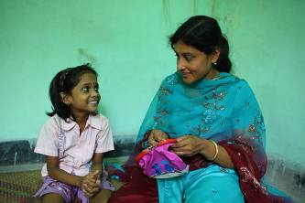
(Smrity features in the Swjan A4 Meet Our Producers card, TIM reference 34552)

Sabina Akhter, known as Smrity, lives in Dhaka and works for Swajan, making beautifully embroidered cards and purses for Traidcraft. Around 850 women like her rely on sales of Swajan products to provide for their families – so each product you buy makes a difference.

As well as educating her seven-year-old daughter, Mimy, and son, Mamun (10), Smrity is able to save 1,000 taka a month from her earnings, so the family’s future is more secure.

“My children are growing up and the expenses are growing. For that reason I am saving,” she said. “I am saving 1000 taka a month and the rest of the money I spend on my daughter and son’s schooling. I am first thinking about my boy, that he gets a proper education and is doing a job. Then my daughter, my wish is that she will become a teacher.”

Smrity’s husband was a driver in the military but is now working for another company as a driver.

I spend my money for my education – Runa’s story

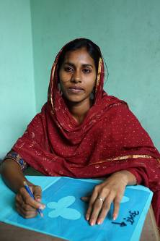
Mahabuba Islam, known as Runa, has been working at Swajan for five years. She completed her secondary school education and is now studying computing. She hopes that if she gets a job working with computers that she will still work part-time at Swajan.

Runa, who lives with her parents, said: “Five years I have been working here. I am living very close to the supervisor and I was interested in doing this job. I spend my money for my education. I am going to a school under the open university. After completing my education I will try to get a job on computer work.”

All the money I devote to my daughter – Nargis’s story

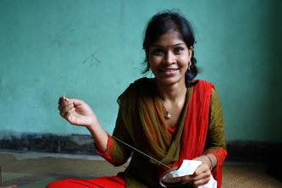
Nargis was widowed in 2009 and working at Swajan helps her to provide for her daughter, Tuli (4).

She lives with her parents and her mother looks after Tuli while Nargis (22) is at work. Nargis know the supervisor at Swajan’s Middle Budda workshop, which is how she heard about the work and applied for a job as an embroiderer.

“My husband died in 2009 and I am now living with my parents,” Nargis said. “I am working for my daughter. All the money I devote to my daughter.”

We learned the importance of quality – Fatima’s story

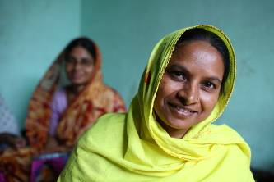
Fatima Begum has been working at Swajan since 2004 and does appliqué and embroidery on Traidcraft cards and purses. She has attended training workshops for the women and described some of the things that were covered.

“We learned the importance of delivery dates,” she said, “the importance of quality and the technique. Also health and safety.”

With new designs being produced for the Traidcraft range, she and the other women often learn new designs.

“With a new design I am looking very closely, then working and showing to the supervisor.

Fatima is married and has three daughters, two of whom are attending school. The oldest daughter is married. Fatima’s husband does building work and before she joined Swajan, Fatima did not work.

“Now I am saving 500 or 600 taka each month and the rest of the money I am spending on my daughters,” she said.

The environment is good – Sumi’s story

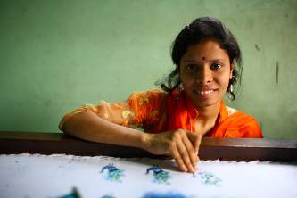
Sumi Akhter (17) joined Swajan with her friend, Rubi, after they left school. She described what she enjoys about working there.

“The environment is good. All the girls are working with good relations and there are no boys here. Part of the money I am giving to my mother and part I spend myself. I feel very glad to see the purses and cards in the catalogue.”

I have a dream for my daughter – Aziza’s story

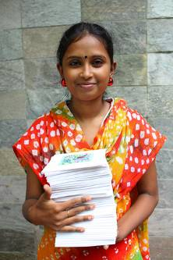
Aziza Munni may not see her daughter, Rumki, very often but the four-year-old is never very far from her thoughts.

Aziza has been working at Swajan for three years and the money that she earns helps to provide for her daughter, who lives with Aziza’s mother some distance from Dhaka, in Mymensingh, following the break-up of Aziza’s marriage. Apart from her own living expenses, all of Aziza’s income goes to provide for her daughter.

“I am sending a part of my income to my mother where my daughter is staying with her,” she said. “I am a long time in not going there, sometimes six months, but often my mother comes to Dhaka and brings my daughter to see me. I speak to her on the phone.”

Aziza checks and packs the Traidcraft orders, inspecting work done by women in some of the rural workshops and finishing off the cards and purses.

“I have a dream to make my daughter better than me, to give her as good as education as I can, to lead a better life than me,” she said, “so everyone can recognise that my girl is doing better, is living a better life.”

I love to do any work – Swity’s story

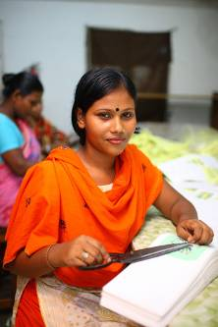
Swity Chandra Das is 20 and began doing embroidery at Swajan a year ago after being trained there for several years. Her uncle also works for Swajan, cutting leather for cushion covers.

“I love to do any work,” she says, “but I am best at doing embroidery.”

She lives with her parents and is able to walk from home to work. She has not started a savings account yet but says she has a target to open one.

“I give my earnings to my mother,” she said. “Anything I need she gets for me.”

On seeing products which she has helped to make in the Traidcraft catalogue she said: “I feel very happy and proud.”.

I will be happy if more orders come – Suborna’s story

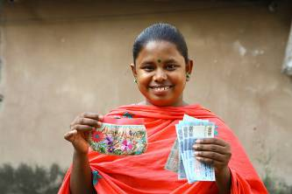
Suborna Rani Das has been working at Swajan since she left school, after studying to Grade 5. She pastes cards and also fastens bows and tassles on purses. She is also a very good cook and prepares food for staff at Swajan when there is no cook available. She lives at home with her parents and learned to cook from her mother.

“I am keeping 500 taka for a deposit scheme in the bank and the rest of the money I give to my father. My father is saving a little amount from my income as well as spending money to maintain the family,” she said.

“I will be happy if more orders come and I can work more and earn more.”

